ISPE San Francisco/Bay Area Chapter
http://www.atdevents.net/register.php

Thursday, September 27th, 2018
5:00 pm - 8:00 pm

BioMarin Facility of the Year Award: Project Review
Panel Discussion with Owner, Architect, Engineer and General Contractor

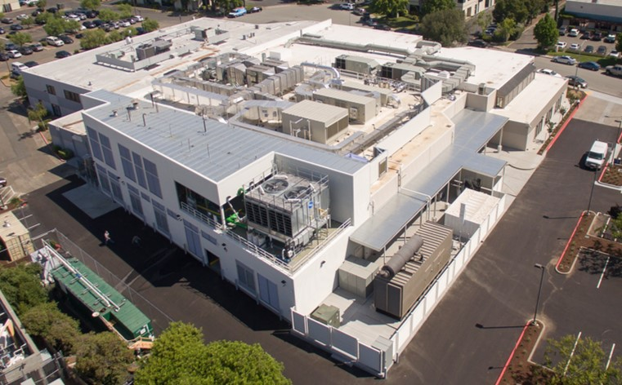

Location:
AC Hotel South San Francisco/Oyster Point Waterfront
1333 Veterans Blvd., South San Francisco, CA 94080

Schedule:
5:00 - 6:00 pm Registration and Networking
6:00 - 6:30 pm Dinner
6:30 - 8:00 pm Presentation

Program Abstract:
In 2017 a cross functional team of experts lead by BioMarin’s Capital Project Management team, CRB and Novo Construction completed one year mission to realize an idea into a GMP released and running Phase 3 gene therapy manufacturing plant.

Come meet the leadership team from BioMarin, CRB and Novo in a presentation and panel discussion as they look back on their journey together one year later.

Panelists
Carl Albertson – Project Director, BioMarin

Logan Kelley -- Sr. Project Manager, Design and Construction, BioMarin

Lisa Rappl -- Sr. Manager, Engineering, BioMarin

Keith Life -- Director of Gene Therapy Manufacturing Operations, Operational Readiness, BioMarin

Kurt Yanagimachi – Principal Scientist, Tech Transfer Lead, BioMarin

Evelyn Burbano – C&Q Lead, ADVENT Engineering

Kory Kaplan – Project Manager, CRB

John Voight – Project Director, Novo Construction

REGISTRATON FORM and INSTRUCTIONS
ISPE San Francisco/Bay Area Chapter
BioMarin Facility of the Year Award: Project Review
Thursday, September 27th, 2018

To Register and Receive an immediate receipt, use our on-line registration: http://www.atdevents.net/register.php

ISPE California Chapter Members: If you are an ISPE Member in California, please do not set up a new account, as you should already be in our system. If you do not know your username or password, please email Rob Fleming (rob.fleming@yahoo.com) for assistance.
ISPE Members of Other Chapters: You will not be in our system unless you have previously set up an account. Please follow instructions for Non Members below. To update your account to a Member account, please forward your confirmation email from ISPE or ISPE Membership information to Rob Fleming (rob.fleming@yahoo.com). We need your Chapter name, your ISPE Member number and expiration date. To retrieve this information, log onto the ISPE website. Click on "Account" on the top right side, then "My Account". Your Membership information (not including your chapter affiliation) is on the left side. Please take a screen shot or make a pdf of the page, then email it along with the name of your chapter to Rob Fleming to update your profile on the atdevents.net site.

Non Members: If you do not have an account on our system, you can set one up on the site using letters (not numbers) as your username. If you need help setting up your account or if you are having problems with the site or need a new password, please email Rob Fleming (rob.fleming@yahoo.com) for assistance.
ALL: If you need help setting up your account or if you are having problems with the site or need a new password, please email Rob Fleming (rob.fleming@yahoo.com) for assistance.

FAX REGISTRATION: Complete the Registration Form with a credit card payment and Fax to (949) 266-8461.

PAY BY CHECK: If paying by check, please make check payable to: ISPE SAN FRANCISCO/BAY AREA CHAPTER, 5319 University Dr., Suite 641, Irvine, CA 92612. Chapter Tax ID #68-0282494. Contact Kimberly Syre: ksyre@cox.net with any questions (or 949-387-9046). Name Badges will be given at the on-site registration desk.

If paying by credit card, please check type of card:
____________ VISA ____________ MASTERCARD ____________ AMERICAN EXPRESS

Name on Card:
Card #:
Expiration Date: Signature:

________$95 ISPE Members
________ $135 Non Members
________ $40 Student or YP Members

NAME:

TITLE:

COMPANY:

ADDRESS with MAIL CODE:

CITY, STATE, ZIP:

PHONE: CELL:

E-MAIL:
Getting There
AC Hotel San Francisco Airport/Oyster Point Waterfront
1333 Veterans Blvd., South San Francisco, CA 94080
Parking is complimentary

Arrive by car, BART, CalTrain, SamTrans or South San Francisco Bay Ferry. Click here for more information:
http://covessf.com/main.cfm?sid=neighborhood&pid=transportation&img=transportation

Driving Directions
From Emeryville:
Take 80 West, follow signs for San Francisco.
Take Bay Bridge to San Francisco (toll bridge).
Keep Left, follow signs for San Jose/US 101 S/Airport.
Merge onto 101 South.
Take Exit 425B for Oyster Point Blvd. E.
Continue onto Oyster Point Blvd.
Use the Left lane to turn Left onto Veterans Blvd.
The venue will be on the Left side.

From San Jose:
Take 101 North toward San Francisco.
Take Exit 425B for Oyster Point Blvd.
Use the middle lane to turn Left onto Dubuque Ave.
Use the 2nd from the right lane to turn Right onto Oyster Point Blvd.
Turn Left onto Veterans Blvd.
The venue will be on the Left side.

From Hayward/East Bay:
Take 92 West San Mateo Bridge (toll bridge).
Use the right 2 lanes to take exit 13B to merge onto 101 North toward San Francisco.
Take Exit 425B for Oyster Point Blvd.
Use the middle lane to turn Left onto Dubuque Ave.
Use the 2nd from the right lane to turn Right onto Oyster Point Blvd.
Turn Left onto Veterans Blvd.
The venue will be on the Left side.

